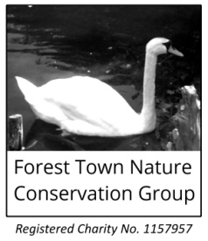
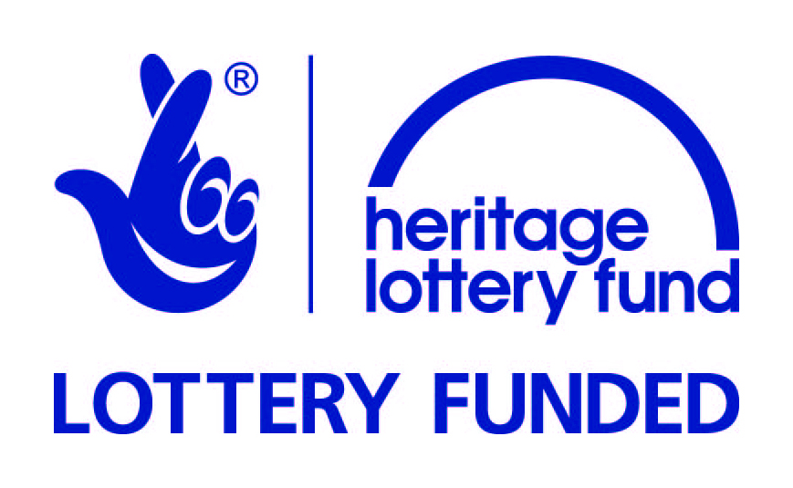
Spa Ponds Heritage Project
Participant Introduction Form

Volunteer Opportunities [tick all that apply]
Project Management Group
We are forming a team of about 10 volunteers who will work together to ensure that the project benefits participants, the wider community and Spa Ponds' heritage. Project Management Group members will receive extra training and mentoring support from MBArchaeology’s Matt Beresford. We will meet about once a month throughout the project, although Group members will not be required to attend each and every meeting. Responsibility for delivering project outputs promised to the Heritage Lottery Fund rests with FTNCG Trustees and not with the Project Management Group. The first meeting of the Project Management Group will be from 11am on Friday 18th November.
- I would like to join the Project Management Group
- I would like to discuss joining the Project Management Group
- I would not like to join the Project Management Group at this time
Workshops (and active involvement between workshops)
From January 2017 there will be a series of monthly workshops as part of the Spa Ponds Heritage Project, alongside other related activities. For example, the History Research Skills Training workshop on Saturday 25th February will be followed by visits to libraries and archives during March and April. For workshop and activity details see: http://www.foresttown.net/heritageproject/ or ask for a separate handout.
- I would like to participate in as many workshops and other Project activities as possible.
- I would like to participate in some of the workshops and other activities (for example, only activities where access is easy, i.e. not on-site at Spa Ponds, or only those activities taking place during weekends and evenings).
- I am not sure which, if any, of the workshops and activities I would like to attend, but I would appreciate being kept informed of forthcoming events and training opportunities, e.g. I would like to be offered spare places as and when these become available.
- I would like to discuss my intended level of participation with one of the organisers.
Oral Histories
Oral histories are stories and memories spoken by people. To help better understand what Spa Ponds (Gara Ponds) means to local people, and to record memories of visiting the site, the Project will include a series of ‘oral history’ interviews. There is an opportunity for a few people to volunteer for a researcher role, which will include attending training sessions focussing on recording and interpreting oral histories.
- I would like to receive oral histories training as a volunteer researcher
- I would like to be interviewed to share my memories of visiting Spa Ponds (Gara Ponds)
- I do not wish to take part in the oral histories part of the Project
Areas of Interest / Level of Previous Experience
 | Interested  (Yes or No) | Previous experience (0-5)  0 = None  5 = Professional
Community archaeology / local history research & presentation
Lidar and other non-intrusive landscape surveying techniques
Guided research visits to archives, incl. libraries and museums
Producing a Heritage Management Plan for Spa Ponds
Recording and interpreting oral histories
Sharing memories of Spa Ponds (Gara Ponds)
Training to help identify and map veteran trees in the area
Project management training
Contributing to displays and/or project website
Helping clear parts of the site to allow landscape surveying
Sharing photographs and/or artefacts connected to Spa Ponds
Taking photographs as part of the Spa Ponds Heritage Project
Others ways you would like to contribute to the Spa Ponds Heritage Project (if any):

General [tick all that apply]
- I would like to be included on the Spa Ponds Heritage Project mailing list
- I would like to discuss the Project with one of the organisers
- I would like to become a member of the Forest Town Nature Conservation Group

Name:

Contact Details (e-mail address and/or postal address):

Telephone and/or mobile number:

Date: Signature:

Please send completed forms to Spa Ponds Heritage Project care of: 25 The Birchlands,
Forest Town, Mansfield NG19 0ER, or spa.ponds@gmail.com or ring (01623) 640134 to discuss.

