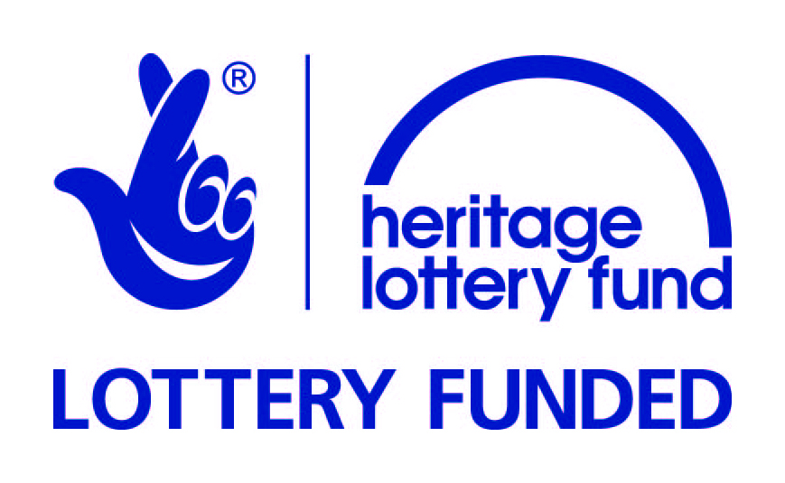
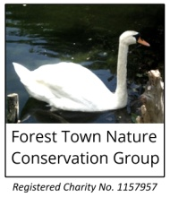

Spa Ponds Heritage Project

'Celebrating 700 years of history'
www.ForestTown.net/HeritageProject
www.Facebook.com/groups/SpaPondsHeritage

Oral Histories of Spa Ponds Nature Reserve (also known as Gara Ponds)
Oral histories are the stories and memories spoken by people. Do you have a story to tell?
The Forest Town Nature Conservation Group have been awarded a Heritage Lottery Fund Sharing Heritage grant for a heritage project. Part of this project is to collect and share the memories local people have had around the local Spa/Gara Ponds. We are also interested in gathering together photos and documents. At the end of the project (October 2017) there will be public displays and events to celebrate the 700th anniversary of this medieval site, together with the development of a community-led Heritage Management Plan
We are interested in your recollections as far back as memory allows up to the present day. This may include experiences, what was there, what was meaningful, valued or special. Your stories/memories will be recorded with a digital recorder and listened to by several researchers. Only small parts of what is said will be written-up for the heritage project and also made available for the public through our website, local libraries, etc. You can have your own personal copy in whichever format is most convenient (paper, CD, etc).
You can remain anonymous or have your name published with your quotes.
At any time in the process you can stop and pull out as you will be under no obligation to continue if you change your mind.
Story recording will take place at Flint Avenue Community Centre, Forest Town, or at an alternative mutually convenient place.
Oral History Researcher Ann Childs can be contacted regarding this project via ann.childs@btinternet.com
Spa Ponds Oral History Participant Agreement Form
- I have read the information about collecting and sharing Spa Ponds / Gara Ponds stories, and I agree to take part, in the knowledge that I am free to change my mind at any time.
Please provide information so we can get in touch with you about the oral history project:
Name
Address

Phone
E-mail
Please sign and date:
Signed Date
Please return to FTNCG c/o 25 Birchlands, Forest Town NG19 0ER or ann.childs@btinternet.com

